AD3002 -HEALTH CARE ANALYTICS
Assignment- 2

Clinical Prediction Models-Heart Disease Predicting
import os
for dirname, _, filenames in os.walk('/kaggle/input'):
for filename in filenames:
print(os.path.join(dirname, filename))
import pandas as pd
#Importing the dataset
df=pd.read_csv("/content/heart_failure_clinical_records_dataset.csv")
df.head()

import os
for dirname, _, filenames in os.walk('/content/drive/MyDrive/Heart_Disease_Prediction.csv'):
for filename in filenames:
print(os.path.join(dirname, filename))
health_data = pd.read_csv('/content/drive/MyDrive/Heart_Disease_Prediction.csv')
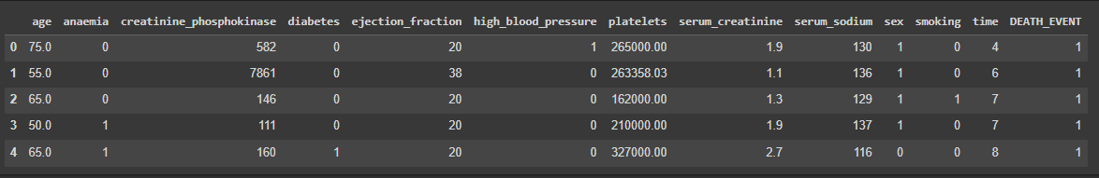
df.info()
<class 'pandas.core.frame.DataFrame'>
RangeIndex: 299 entries, 0 to 298
Data columns (total 13 columns):
# Column Non-Null Count Dtype
--- ------ -------------- -----
0 age 299 non-null float64
1 anaemia 299 non-null int64
2 creatinine_phosphokinase 299 non-null int64
3 diabetes 299 non-null int64
4 ejection_fraction 299 non-null int64
5 high_blood_pressure 299 non-null int64
6 platelets 299 non-null float64
7 serum_creatinine 299 non-null float64
8 serum_sodium 299 non-null int64
9 sex 299 non-null int64
10 smoking 299 non-null int64
11 time 299 non-null int64
12 DEATH_EVENT 299 non-null int64
dtypes: float64(3), int64(10)
memory usage: 30.5 KB

df.isnull().sum()
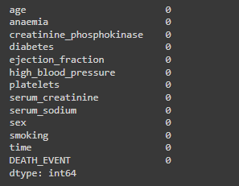

df.shape
import matplotlib as plt
import seaborn as sns
corr_matrix=df.corr()
# Plot a heatmap
sns.heatmap(corr_matrix, annot=True, cmap='coolwarm')
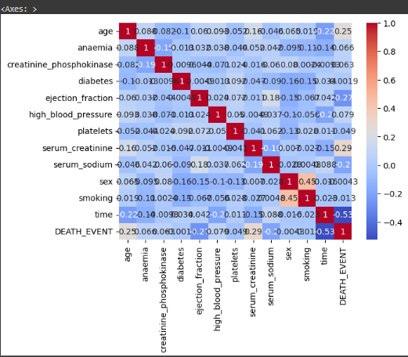
df.DEATH_EVENT.unique()
df.drop(["time","ejection_fraction","serum_sodium","platelets"],axis=1,inplace=True)
df.head()
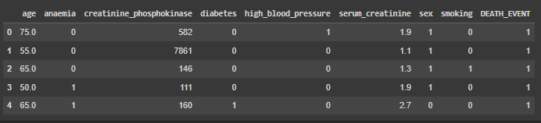
import pandas as pd
import matplotlib.pyplot as plt
import seaborn as sns
# Visualizing the columns
# Example 1: Creating a bar plot for 'sex' column
plt.figure(figsize=(8, 6))
sns.countplot(x='sex', data=df)
plt.title('Count of Male and Female Patients')
plt.xlabel('Sex')
plt.ylabel('Count')
plt.show()
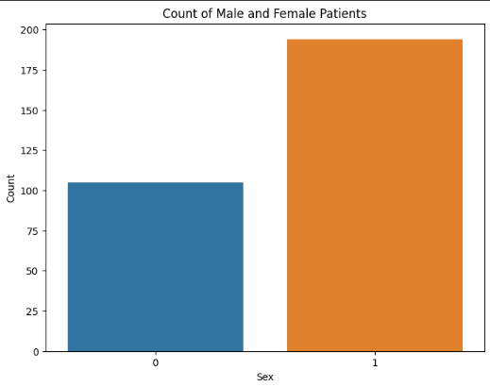
# Example 2: Creating a histogram for the 'age' column
plt.figure(figsize=(8, 6))
sns.histplot(data=df, x='age', bins=30, kde=True, color='skyblue')
plt.title('Distribution of Age')
plt.xlabel('Age')
plt.ylabel('Count')
plt.show()
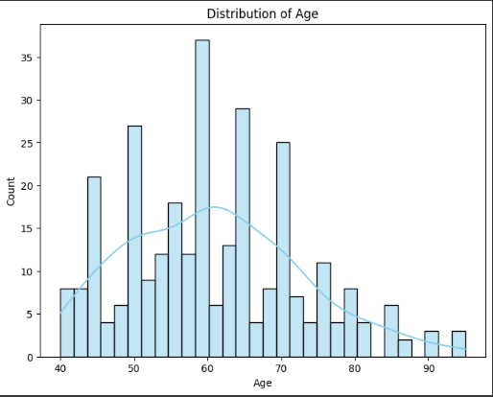

# Example 3: Creating a box plot for 'DEATH_EVENT' column
plt.figure(figsize=(8, 6))
sns.boxplot(x='DEATH_EVENT', y='age', data=df)
plt.title('Age vs Death Event')
plt.xlabel('DEATH_EVENT')
plt.ylabel('Age')
plt.show()
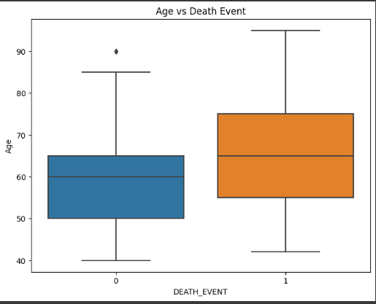

# Example 4: Creating a scatter plot for 'serum_creatinine' and 'serum_sodium' columns
plt.figure(figsize=(8, 6))
sns.scatterplot(x='serum_creatinine', y='serum_creatinine', data=df, hue='DEATH_EVENT')
plt.title('Scatter plot of Serum Creatinine vs Serum Creatinine')
plt.xlabel('Serum Creatinine')
plt.ylabel('Serum Creatinine')
plt.show()

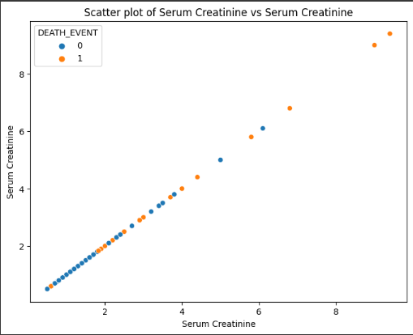

X=df.iloc[:,:-1]
Y=df.iloc[:,-1]
print(X)
print(Y)
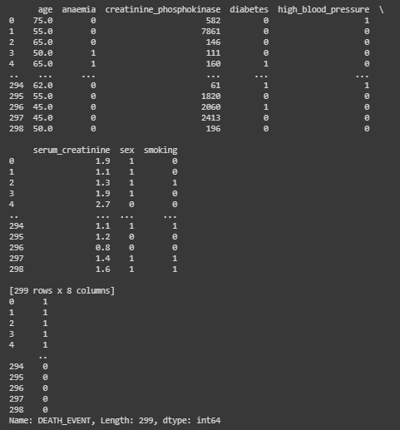

#Scaling the data
from sklearn.preprocessing import StandardScaler
sc=StandardScaler()
X=sc.fit_transform(X)
#splitting the dataset
from sklearn.model_selection import train_test_split
X_train,X_test,Y_train,Y_test=train_test_split(X,Y,random_state=2,test_size=0.2)
#Using logistic regression
from sklearn.linear_model import LogisticRegression
model=LogisticRegression()
model.fit(X_train,Y_train)
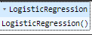
y_pred=model.predict(X_test)
from sklearn.metrics import confusion_matrix
print(confusion_matrix(Y_test,y_pred))
[[39 4]
[12 5]]
from sklearn.metrics import classification_report
print(classification_report(Y_test,y_pred))
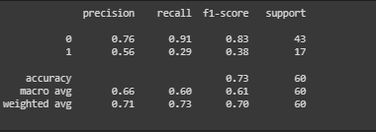
from sklearn.svm import SVC
classifier=SVC(kernel='rbf')
classifier.fit(X_train,Y_train)
y_pred=classifier.predict(X_test)
print(classification_report(Y_test,y_pred))
print(confusion_matrix(Y_test,y_pred))
